**Kinetic Friction and Coefficients of Friction**

**Pre-lab questions**

1. What is the goal of this experiment? What physics and general science concepts does this activity demonstrate to the student?
2. What is the mathematical form of kinetic friction?
3. Should the friction coefficient depend on the contact area?

The goal of the experiment is to study the nature of sliding friction and changes in friction force with differing surfaces in contact.

**Introduction**

The friction force is the resistive force encountered when one surface slides over a second surface. When viewed close up, the detailed nature of friction forces is quite complex. However, a simple linear model serves most everyday purposes in describing the action of friction for us.

As a resistive force, friction always *opposes* the direction of motion of an object. Since sliding friction only exists between two surfaces in contact, it also depends on the force (called the normal force) that pushes the surfaces against each other. And, the force of friction depends on the nature of the surfaces in contact, their composition and surface roughness. The empirical **model for contact friction** says the maximum friction force *F*f = μ*N*, where μ is the coefficient of friction (between the pair of surfaces) and *N* is the normal force. (*Normal* is used here in the mathematical sense of *perpendicular*. The normal force is perpendicular to the surfaces in contact.)

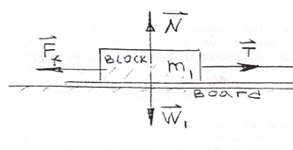

In the diagram, **W**1 = *m*1**g** is the downward force due to gravity that is being balanced by the upward normal force, **N**. **T** is the applied force trying to move block *m*1, while **F**f is the friction force resisting that tendency toward motion. If the *magnitude* of the applied force *T* is greater than that of the friction force *F*f, the block *m*1 will accelerate. If *T* = *F*f, then the net force on the block *m*1 is zero and it will move at a constant speed.

There are two types of frictional forces -- **static friction** when an object is at rest and **kinetic friction** when an object slides. From everyday life, we know it is usually harder (requires a larger force) to get an object to begin to slide that it does to keep it in motion. Since both are related to the same normal force, the coefficient of static friction μs can be greater than the coefficient of kinetic friction, μk. While *F*f = μk*N*, for sliding (kinetic) friction, *F*f ≤ μs*N*, for static friction. That is, static friction supplies just enough resistive force to cancel out the applied force trying to move an object – up to its maximum value *F*f = μs*N*. Once that maximum value is reached, the object begins to slide and kinetic friction takes over.

Equipment:

Pasco Dynamics System, acoustic motion sensor, force sensor, assorted friction trays, motorized cart, compact masses, string, bubble level, balance scale.

Experiment

The Friction Trays have different materials on their bottom surface. The Motorized Cart (see Fig. 1) is used to pull the trays in a controlled manner along the track, as the Force Sensor directly measures the frictional force. All parameters are investigated, including speed, normal force, and surface area.

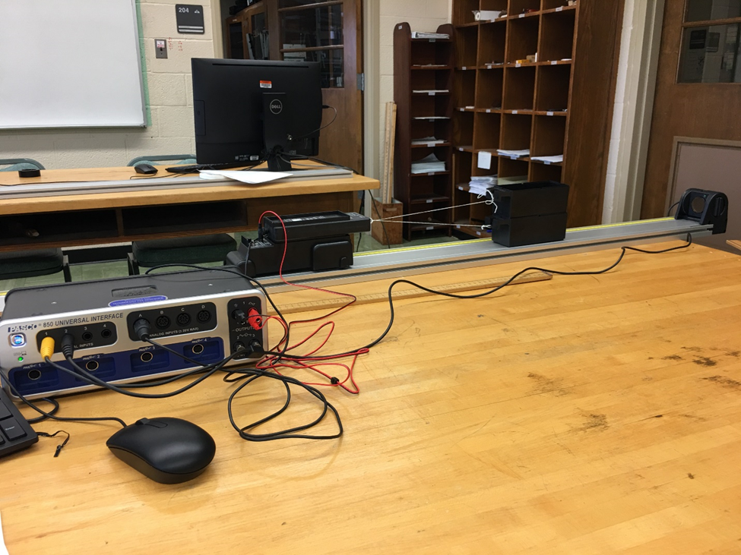

Figure 1: Measuring Sliding Friction

Setup

1. Set up the track as shown in Figure 1, and use the bubble level and the adjustable feet to level the track.
2. Connect the Motion Sensor to the PASPORT input P1, and attach it to the track. Make sure the switch on the top of the Motion Sensor is set to “cart”.
3. Connect the Force Sensor to the PASPORT analog input. Place the Cart/Force Sensor assembly on the track. Change the sample rate to 10 Hz (at bottom of screen). Open the properties for the Force Sensor in the Data Summary and check the Change Sign box.

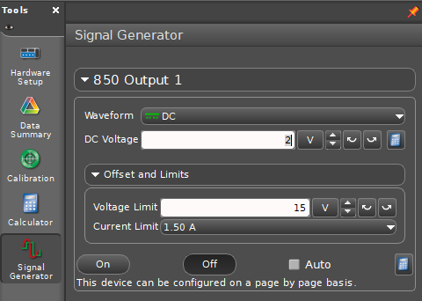

Figure 2: Signal Generator

1. Connect the Motorized Cart power cord to Output #1, and make sure the cart is on the OFF/EXTERNAL setting. With the DC Voltage set to 2 volts, turn the output on and off to ensure that the cart is working. You can open and close the output window by clicking on the Signal Generator icon in the tool palette (see Fig. 2).
2. Connect the Friction Trays to the Force Sensor using string as shown in Figure 3. The lower tray should have the black felt surface. You must always pull with two carts stacked, so that the Force Sensor pulls level. For the top tray, use one of the trays with the white plastic on the bottom. The lower end of the string is just looped around the tray hook: This makes it easier to swap out the lower tray to change the surface.
3. Place both silver cart masses in the upper friction tray. If the Motorized Cart has trouble pulling the load, add the black Compact Masses to the cart in front of the Force Sensor. If you still have trouble, remove one of the silver masses from the tray.

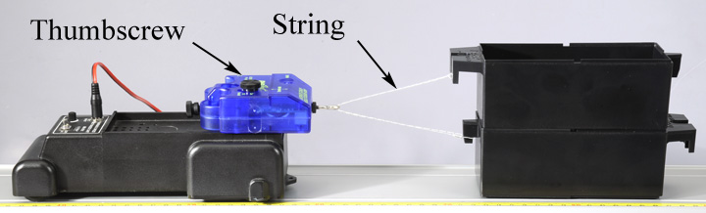

Figure 3: Towing the Friction Carts

1. Make a graph of velocity vs. time, add a plot area () and put force in the second plot area. Select a Quick-Calc for the velocity (-v) to change the sign of the velocity so it will be positive. Click on the velocity units of the graph and select cm/s.

Procedure: Measuring Speed and Force

1. Position the cart and trays at the far end of the track, opposite the motion sensor. Note this spot as the starting position for all the runs.
2. Open the Signal Generator window, and set the voltage for 1.0 volt DC. The output should be set on Auto, which will automatically turn on the cart when you start recording data, and stop the cart when data collection is ended.
3. Click on Record. Stop recording **before** the cart hits the motion sensor.
4. If the Motorized Cart can't pull the load, increase the voltage to 1.5 volts.
5. Adjust the Motion Sensor if necessary to get good velocity data.
6. The force data will be noisy, but you will be able to get an average reading. Try using the Smoothing tool () in the Graph tool palette. The trays will move at a relatively constant speed when the string tension (measured by the force sensor) equals the friction force.

Changing Speed:



1. 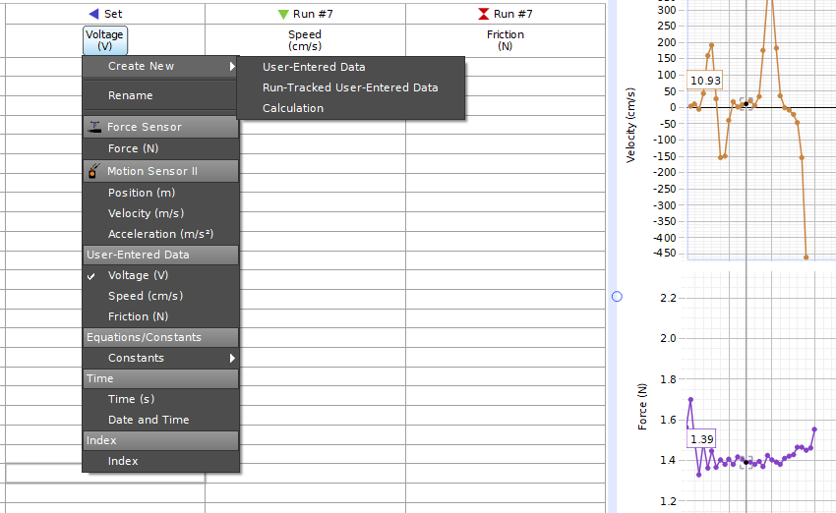Using the control at the bottom of the screen, change the sample rate of all the sensors to a common rate of 20 Hz.

Figure 4: Create mixed-input data table.

1. Create a table with three columns, as shown in Fig. 4: In the first column, create a User-Entered data set called Voltage (units of V); In the second column, create a Run-Tracked User-Entered data set called Speed (units of cm/s) ); In the third column, create a Run-Tracked User-Entered data set called Friction (units of N).
2. Use the Coordinates tool () to measure the speed and the frictional force. Pick a time that has reasonably good data for both.
3. Record your values in the table.
4. Repeat for voltages of 1.5 V, 2.0 V, 2.5 V, etc. up to 5.0 volts.
5. Create a graph of Friction vs. Speed. What trend can you see in the data? How does the frictional force depend on the speed?
6. Take the ratio of the fastest speed/ slowest speed. By what factor did you vary the speed? By what factor did the resulting frictional force change? Would you say that the friction changed a little or a lot?
7. Does your data support the concept that it is a useful approximation to assume that sliding friction is independent of speed?

Changing Normal Force:

1. Create a table with four columns, as shown in Fig. 5: In the first column, create a Run-Tracked User-Entered data set called Tray (unitless); In the second column, create a User-Entered data set called Mass (units of kg); In the third column, create a calculation (units of Newtons) Normal Force = [mass (kg), ▼][Accel due to gravity (m/s²)] (*Note:* *When you type* ***[*** *in the calculation box it will bring up the selection box allowing you to choose data columns and constants.*); In the fourth column, select Friction.
2. Replace the lower felt tray with a tray that has a white plastic surface. Start with both trays empty, and use the balance to determine the mass. Calculate the combined weight, and enter this as the normal force in the table below.
3. Set the voltage output to 1.5 volts. Click on Record. Stop recording before the cart hits the motion sensor.
4. Using the graph, note the approximate speed and, if necessary, adjust the voltage in later runs to keep the speed the same.
5. Record the frictional force in the table. Add the 4 mass bars (one at a time) and repeat. You should end up with 5 values.
6. Create a graph of Friction vs. Normal Force1. What trend can you see in the data? Try a linear Curve Fit. Is your data linear?
7. Most text books make the assumption that *F*f = μ*N*, where *F*f = friction, *N*= normal force, and μ = the friction coefficient. Does your data support this assumption? What are the units for μ?

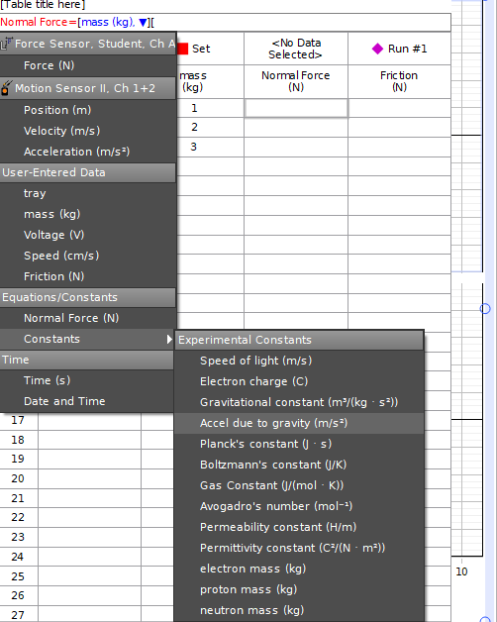

Figure 5: Normal force vs. friction data table

Changing Surface Material:

1. Create a table with four columns:
   1. In the first column, create a User-Entered data set called Cart Material (unitless);
   2. In the second column, create a User-Entered data set called Normal Force (units of N);
   3. In the third column, create a User-Entered data set called Frictional Force (units of N);
   4. In the fourth column, create a calculation (unitless)

‎μ ‎ = [Frictional Force (N)‎]/[Normal Force (N)‎]

1. Remove all but one of the mass bars. Click on Record, and use the graph to measure the frictional force.
2. Coefficients are always between two surfaces. What is the other surface?
3. Replace the lower plastic tray with a tray with black felt and repeat. Replace the lower felt tray with a tray with brown cork material and repeat.
4. Which material has the largest coefficient? Which has the least?
5. What type of friction are you measuring: Static or Sliding (Kinetic) friction?

Changing Area:

1. Connect the trays as shown in Figure 3. The bottom two trays should both be the white plastic. Place one of the silver mass bars in each of the two upper trays, and perform the pull test as before.
2. Measure the force from the graph and use equation (1) to calculate the coefficient of friction for the white plastic material.
3. How does this value (with twice the surface area) compare to your previous values? Most text books assume that sliding friction is independent of surface area. Do you agree?

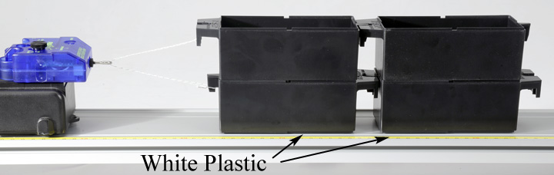

Figure 6: Changing Surface Area

Static Friction:

1. Increase the sample rate of the force sensor to 2 kHz (the maximum).
2. On the graph, change the negative velocity to the Position.
3. Remove the trailing two trays, returning to the original set-up pulling only two trays. The lower tray should be cork. Place both silver masses in the upper tray, and both black masses on the Motorized Cart in front of the Force Sensor. If the cart won't pull the trays, remove one of the silver masses.
4. 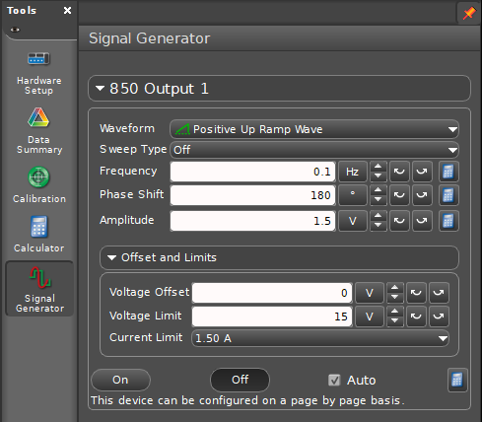Open the Signal Generator (see Fig. 7) and set the waveform to Positive Up Ramp Wave. Set the frequency to 0.1 Hz, the phase shift to 180º, and the amplitude to 1.5V. The frequency generator is now set to ramp up its voltage, to slowly increase the pulling force over a 10 second period. If the trays don't break free and move in that time, increase the voltage amplitude.

Figure 7: Setting the signal generator

1. Click on Record. As soon as the tray starts to slide, click on stop.
2. Examine your data on the graph. You can see from the position data where the tray starts to slide, and the value of the sliding friction force after this point. In the time before this, what does the force data look like?
3. Most materials show a value for static friction slightly larger than for sliding (kinetic) friction. Does your data support this? What is your largest value for the Static coefficient?